**City Guide**

**First Increment**

**Under Guidance of**

**YUGYUNG LEE**

**Submitted by**

**Sreekailash Depuru (ID: 16169609)**

**Sainath Mandava (ID: 16170273)**

**Divya Sree Vintha (ID: 16172320)**

**Ravisha Thalapalli (ID: 16171645)**

**System Architecture Diagram**

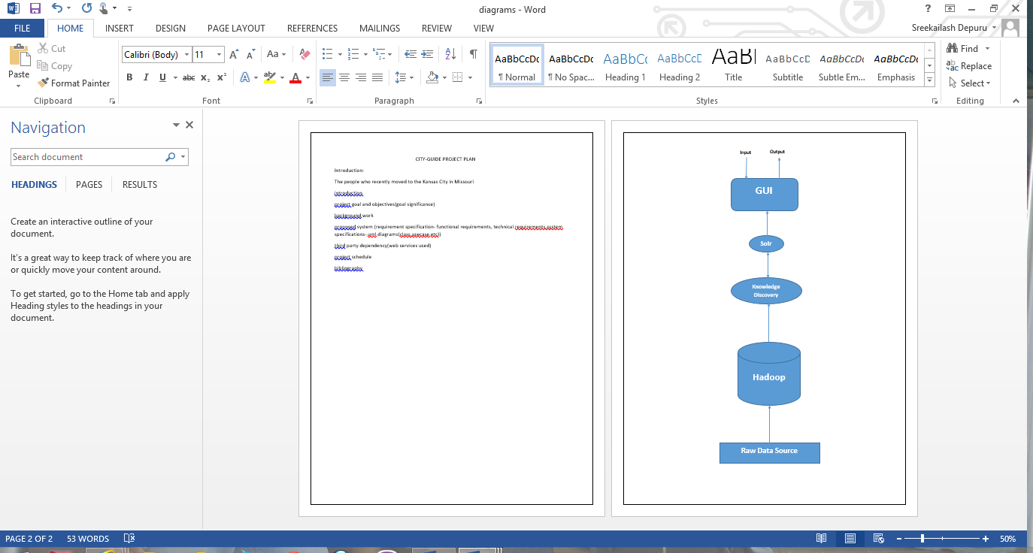

**Fig: Project Layout**

The architecture of the project is the same as of the simple Hadoop project which uses Solr to output the data. In our project we use Recommender System to suggest users about the housing options available in their selected range of price. The search criteria depend on the requirements specified by the users.

**Domain Model**

* **Data Sources**:

https://data.kcmo.org has provided us with the datasets of various institutions and establishments. These datasets provide us with the information to be provided to the user.

* **Methodologies and Algorithms:**

We are going to implement naïve Bayes classification and also recommendation system. Naïve Bayes classification is used to separate the data in a form of clusters where the search criteria can be made easier. Recommender system is used to provide suggestions to the user based on the prerequisites.

* **Analytic Tools:**
* Android Mobile Client Application for developing the User Interface.
* Recommender system using Apache Solr and RestFul services.
* Classification System to divide the data into clusters.
* **Analytical Tasks:**

Refining the datasets to map each and every data. Recommending to the user based on his/her detailed requirements.

**WORK-FLOW**

The Data refining and storage process is ongoing as we got some technical issues in dealing with the Hadoop. In the meanwhile we designed our Graphical User Interface which can be integrated with the output of backend. The front-end of the application is designed in Android.

The back-end process is on progress where we are dealing with the data refining and storage. The data sets which we collected need to be refined according to our project requirement so that the retrieval of data can be made easier. This phase is on progress.

**Application Specification**

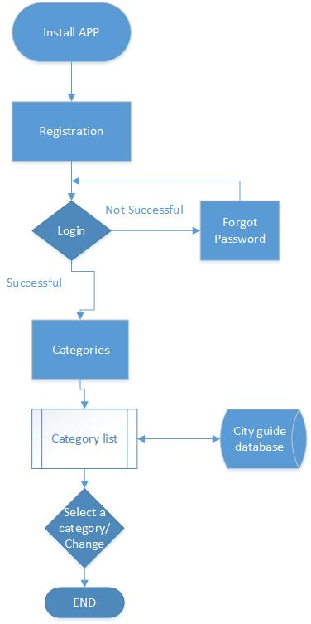

**Fig: Flowchart**

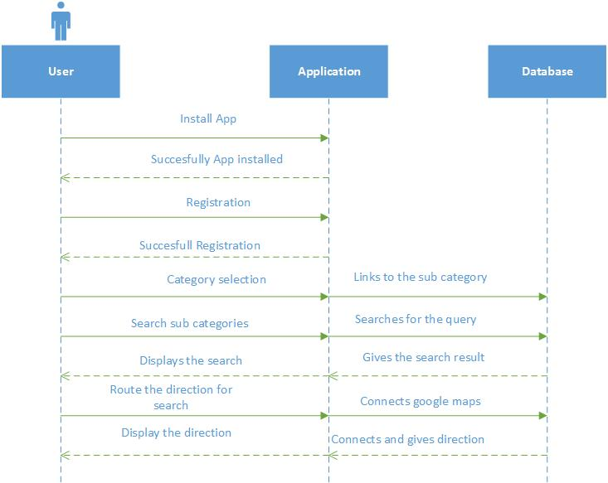

**Fig: Sequence Diagram**

**Implementation**